|  |  |  |
| --- | --- | --- |
| **Game Dev** | *Console Game Programming* | Exercise 2 |

**PROJECT Console Programming with Python – Ladders and Snakes**

**Objective** To use Python to demonstrate a game - based Console Application.

***PROJECT DESCRIPTION***

Create a Python application for the following scenario:

**Ladders and Snakes** (also known as **Snakes and Ladders**) is a classic board  
 game for 2 or more players. The game features a numbered board with a grid   
 layout, typically ranging from 1 to 100. Players take turns rolling a die to move   
 their pieces across the board. The goal is to reach the last square (usually 100)

first.

**Summary:**

**Game Board:** A numbered grid for example of 1 to 100 with various ladders and

snakes placed on it.

**Pieces:** Each player has a piece or token that moves according to the roll of the  
 die.

**Ladders:** Ladders on the board allow players to move up to a higher-numbered

square, helping them advance more quickly.

**Snakes:** Snakes cause players to slide down to a lower-numbered square,   
 hindering their progress.

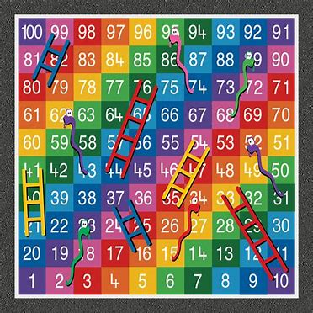

***Information About This Project***

For example, a game of snakes and ladders or any other game whose moves are determined entirely by dice is a Markov chain.

A **Markov chain** is a mathematical system that experiences transitions from one state to another according to certain probabilistic rules. The defining characteristic of a Markov chain is that no matter how the process arrived at its present state, the possible future states are fixed.

In other words, a Markov chain is a sequence of events where the probability of each event depends only on the state attained in the previous event .

Markov chains are used in many fields such as physics, chemistry, economics, finance, and computer science. They are used to model systems that change over time and are useful for predicting future events based on past events.

**Rules:**

1. **Starting the Game:**
   * Each player places their piece on the starting square (usually 1).
2. **Movement:**
   * Players take turns rolling a die to determine how many squares to move their piece.
   * Players move their piece forward by the number rolled.
3. **Ladders:**
   * If a player lands on the base of a ladder, they climb up to the top of the ladder and continue their turn from there.
4. **Snakes:**
   * If a player lands on the head of a snake, they slide down to the tail of the snake and continue their turn from there.
5. **Winning the Game:**
   * The first player to reach the final square (usually 100) wins the game.
   * Some variations require an exact roll to land on the last square; otherwise, the player must wait and roll again.
6. **Special Rules:**
   * Some versions include additional rules, such as rolling doubles to get another turn or using special tokens.

***Steps to Complete This Project***

**STEP 1**  **Open VSC**

Open the folder to your laddersAndSnakes.py file

**STEP 2**  **Play the Game**

After you run your program, run the program with multiple executions and observe the game in action!